Programming Assignment #1
(for Ch 1 and 2)

Problem Description

Write an application that asks the user to enter two numbers, obtains the two numbers from the user and prints the sum, product, difference, and quotient (division) of the two numbers. Use the techniques shown in Fig. 2.7.

Note: This problem is question 2.15 on page 66.

Sample Run

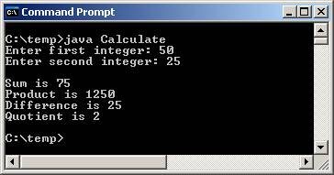

Problem Requirement
a) Your program must produce the prompt and the output the same as given.
b) Your program should run correctly with the same inputs and outputs as given in the sample run.

